STS Atrial Fibrillation (Maze)
Surgeon Worksheet V2.9

Lesion Location: □Primarily Epicardial □Primarily Intracardiac
Method of Lesion Creation: (select all that apply)
□Radiofrequency (If Yes →) Bipolar: □Yes □No
□Cut-and-sew
□Cryo

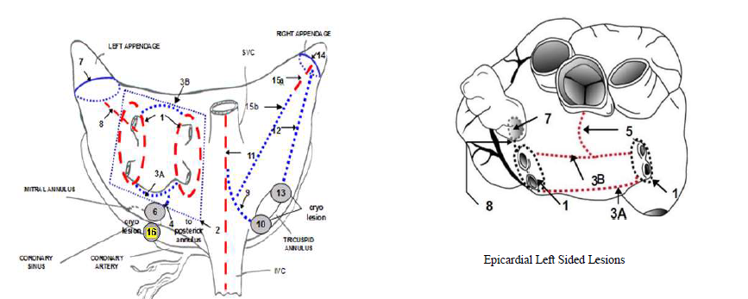

□1 Bilateral Pulmonary Vein Isolation | □9. Intercaval Line to Tricuspid Annulus (“I” Lesion)
□2. Box Lesion Only | □10. Tricuspid Cryo Lesion, Medial
□3a. Inferior Pulmonary Vein Connecting Lesion | □11. Intercaval Line (SVC and IVC)
□3b. Superior Pulmonary Vein Connecting Lesion | □12. Tricuspid Annular Line to RAA
□4 Posterior Mitral Annular Line Lesion | □13. Tricuspid Cryo Lesion
□5 Pulmonary Vein Connecting Lesion to  Anterior Mitral Annulus | □14. RAA Ligation/Removal/Obliteration
□6. Mitral Valve Annular Lesion | □15a. RAA Lateral Wall (Short)
□7. LAA/Removal Obliteration | □15b. RAA Lateral Wall to “I” Lesion
□8. Pulmonary Vein to LAA Lesion | □16. Coronary Sinus Lesion

